PROGRAM 5
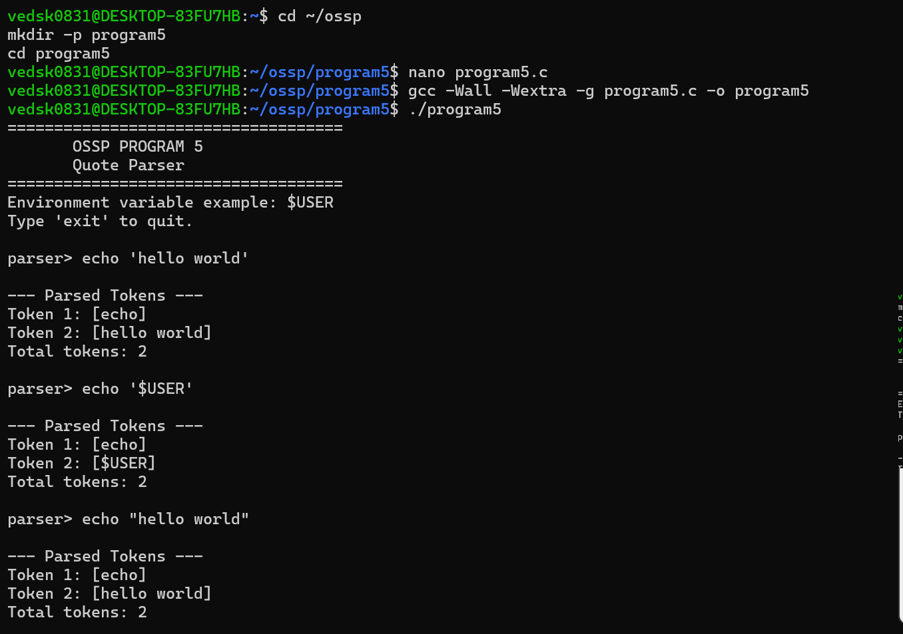
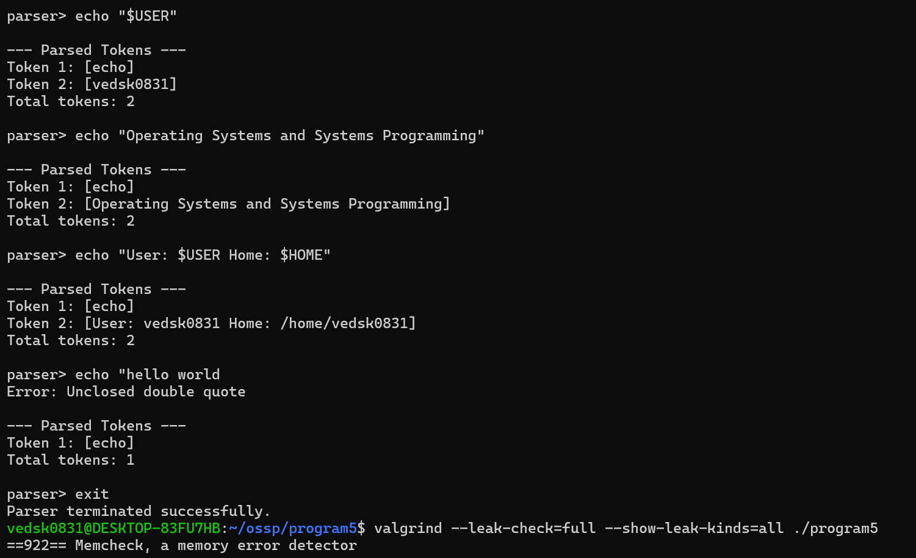
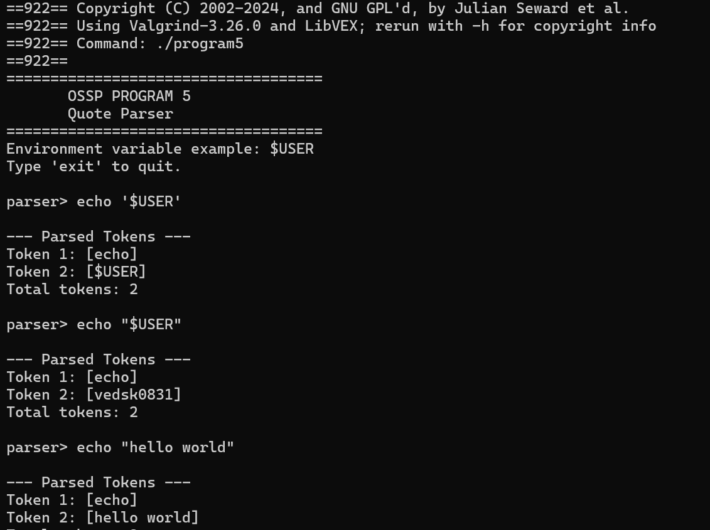
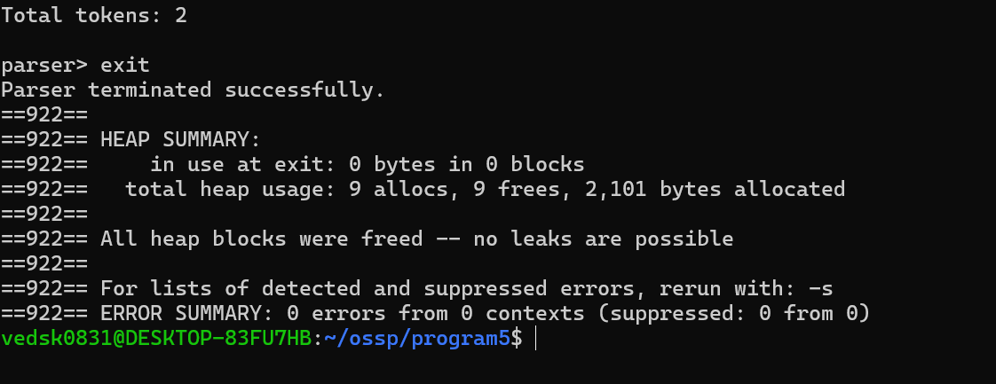
#include <stdio.h>
#include <stdlib.h>
#include <string.h>

#define MAX_INPUT 1024
#define MAX_TOKENS 100

typedef struct {
char *tokens[MAX_TOKENS];
int count;
} TokenList;

/* Add token */
void add_token(TokenList *list, const char *token)
{
if (list->count >= MAX_TOKENS) {
printf("Error: Too many tokens\n");
return;
}

list->tokens[list->count] = malloc(strlen(token) + 1);

if (list->tokens[list->count] == NULL) {
perror("malloc");
exit(EXIT_FAILURE);
}

strcpy(list->tokens[list->count], token);
list->count++;
}

/* Free tokens */
void free_tokens(TokenList *list)
{
for (int i = 0; i < list->count; i++) {
free(list->tokens[i]);
list->tokens[i] = NULL;
}

list->count = 0;
}

/* Expand environment variable */
char *expand_variable(const char *variable)
{
char *value = getenv(variable);

if (value == NULL) {
return strdup("");
}

return strdup(value);
}

/* Parse command */
void parse_command(const char *input, TokenList *list)
{
int i = 0;
char token[1024];
int token_pos;

list->count = 0;

while (input[i] != '\0') {

/* Skip spaces */
while (input[i] == ' ' || input[i] == '\t') {
i++;
}

if (input[i] == '\0') {
break;
}

token_pos = 0;

/* SINGLE QUOTES */
if (input[i] == '\'') {

i++;

while (input[i] != '\0' && input[i] != '\'') {
token[token_pos++] = input[i++];
}

if (input[i] == '\'') {
i++;
} else {
printf("Error: Unclosed single quote\n");
return;
}

token[token_pos] = '\0';
add_token(list, token);
}

/* DOUBLE QUOTES */
else if (input[i] == '"') {

i++;

while (input[i] != '\0' && input[i] != '"') {

/* Environment variable */
if (input[i] == '$') {

i++;

char variable[256];
int vpos = 0;

while (
input[i] != '\0' &&
(
(input[i] >= 'A' && input[i] <= 'Z') ||
(input[i] >= 'a' && input[i] <= 'z') ||
(input[i] >= '0' && input[i] <= '9') ||
input[i] == '_'
)
) {
variable[vpos++] = input[i++];
}

variable[vpos] = '\0';

char *value = expand_variable(variable);

for (int j = 0; value[j] != '\0'; j++) {
token[token_pos++] = value[j];
}

free(value);
}
else {
token[token_pos++] = input[i++];
}
}

if (input[i] == '"') {
i++;
} else {
printf("Error: Unclosed double quote\n");
return;
}

token[token_pos] = '\0';
add_token(list, token);
}

/* NORMAL TOKEN */
else {

while (
input[i] != '\0' &&
input[i] != ' ' &&
input[i] != '\t'
) {
token[token_pos++] = input[i++];
}

token[token_pos] = '\0';
add_token(list, token);
}
}
}

/* Display tokens */
void print_tokens(const TokenList *list)
{
printf("\n--- Parsed Tokens ---\n");

for (int i = 0; i < list->count; i++) {
printf("Token %d: [%s]\n",
i + 1,
list->tokens[i]);
}

printf("Total tokens: %d\n", list->count);
}

int main()
{
char input[MAX_INPUT];
TokenList list;

printf("====================================\n");
printf(" OSSP PROGRAM 5\n");
printf(" Quote Parser\n");
printf("====================================\n");

printf("Environment variable example: $USER\n");
printf("Type 'exit' to quit.\n\n");

while (1) {

printf("parser> ");

if (fgets(input, sizeof(input), stdin) == NULL) {
break;
}

input[strcspn(input, "\n")] = '\0';

if (strcmp(input, "exit") == 0) {
break;
}

if (strlen(input) == 0) {
printf("Error: Empty command\n\n");
continue;
}

parse_command(input, &list);

print_tokens(&list);

free_tokens(&list);

printf("\n");
}

printf("Parser terminated successfully.\n");

return 0;
}

